VLOOKUP (Vertical Lookup) is a function that searches for a certain value in a column to return a corresponding piece of information

VALUE is a function that converts a text string that represents a number to a numerical value

Absolute reference is a reference that is locked so that rows and columns won’t change when copied

MATCH is function used to locate the position of a specific lookup value

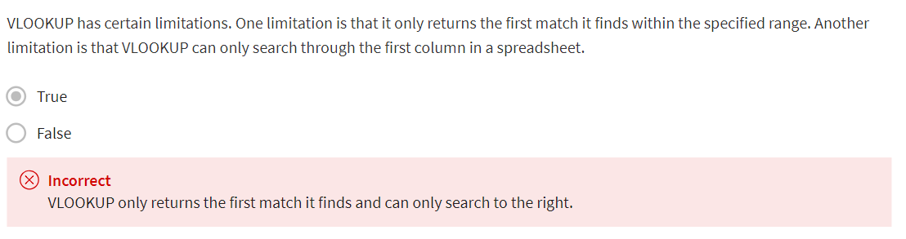

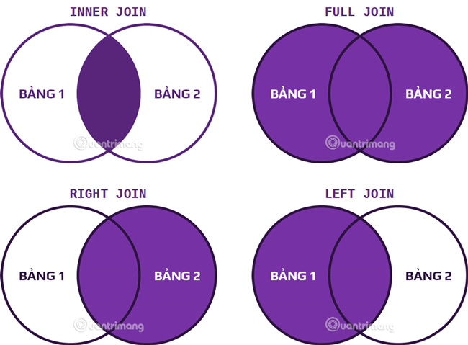

JOIN is a SQL clause that is used to combine rows from two or more tables based on a related column

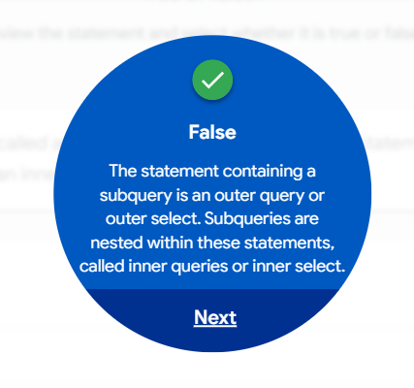

**Glossary terms from module 3**

**Terms and definitions for Course 5, Module 3**

**Absolute reference:** A reference within a function that is locked so that rows and columns won’t change if the function is copied

**Aggregation:** The process of collecting or gathering many separate pieces into a whole

**Aliasing:** Temporarily naming a table or column in a query to make it easier to read and write

**COUNT DISTINCT:** A SQL function that only returns the distinct values in a specified range

**Data aggregation:** The process of gathering data from multiple sources and combining it into a single, summarized collection

**INNER JOIN :** A SQL function that returns records with matching values in both tables

**JOIN:** A SQL function that is used to combine rows from two or more tables based on a related column

**LEFT JOIN:** A SQL function that will return all the records from the left table and only the matching records from the right table

**LIMIT:** A SQL clause that specifies the maximum number of records returned in a query

**MATCH:** A spreadsheet function used to locate the position of a specific lookup value

**OUTER JOIN:** A SQL function that combines RIGHT and LEFT JOIN to return all matching records in both tables

**RIGHT JOIN:** A SQL function that will return all records from the right table and only the matching records from the left.

**Subquery:** A SQL query that is nested inside a larger query

**VALUE:** A spreadsheet function that converts a text string that represents a number to a numeric value

